|  |  |  |  |
| --- | --- | --- | --- |
| **Description** | Various information are being entered to the login boxes to ensure that only allowed users can pass | | |
| **Plan & Results** | | | |
| **Test Name** | **Test Method** | **Expected Result** | **Test Status** |
| 1.1 Insert invalid user name & password | Invalid or information that does not exist in the database are entered in the fields | Error message should be shown | Success |
| 1.2 Enter correct username and incorrect password | Enter a valid username which has been registered in the database but incorrect password | Error message should be shown | Success |
| 1.3 Enter valid login details | Enter correct user name and password | User must be logged in should be redirected to dashboard | Success |

1 Login

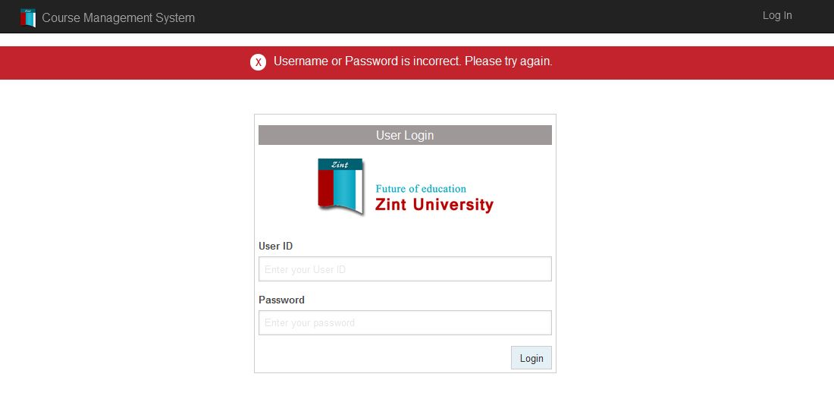

Figure 1 - 1.1 Screen after entering invalid login details